**Fundamental Analysis**

It's all about knowing a company in-depth with qualitative and quantitative approaches.

Whereas

**Qualitative: Quantitative**

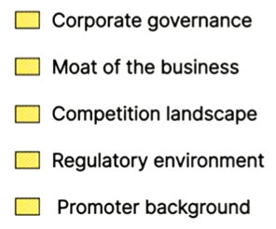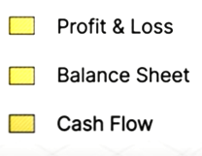

The fundamental approach is used for long-term investment, expecting a tremendous compounded return.

**Reading the annual report of the company:**

The annual report consists of all financial and non-financial information of the company.

As per the fundamental approach, we will be looking only relevant sections:

1. **Management Discussion and Analysis**
2. Business Strategy of the company: Research & Development
3. Growth Prospects of the company: Segments, Performance, Revenue.
4. The risk that the company faces: Subsidiary companies
5. **General Shareholder Information**: Directors and their equity % and shareholdings.
6. **Consolidated Financial Statements**
7. Standalone Statement
8. Consolidated Statment ( **Recommended**: It includes the financial report of subsidiary companies' holdings as well.)

**Profit and Loss Statement.**

1. Revenue made by the company in a given year
2. Expenses made by the company in a given year
3. Tax company paid in a given year
4. Net Profit made in a given year

**Other income comprises** any income coming in indirect form.

Ex: Dividend income, non-operating activities, interest income.

* **PAT:** Profit after tax, also called the bottom line of the company.

Note: PNL is always for a given year whereas the Balance sheet is over after over a year.

**Balance Sheet:**

The major components are:

1. **Assets: Non-Current and Current Assets**

**Non-current Assets:** These are assets that can have long-term benefits to the company.

Property, plant, machinery, financial investments like mutual funds or bonds, and patents.

**Current Assets:** Economic output within a 1-year timeframe.

Ex: Inventories, trade receivables, loans and repayments, cash and cash balances held with the bank.

**The Sum of current and non-current assets is the total assets held by the company.**

**Note:** Always focus more on the biggest amounts and the note associated with them to understand the section better.

1. **Liabilities: Non-Current and Current Liabilities**

**Liabilities:** Financial obligations of the company.

**Liabilities Non-Current:** The company's financial obligations that can be completed over a period of years. (ex: 4-5 years)

**Liabilities** **Current**: Financial obligations of the company that can be completed within a period of years.

1. **Equity:** Share Capital and Reserves and surpluses.

**Share Capital:** Promoter money given as early investment.

**Reserves and surpluses:** Profits flowing from PNL statements are reserved for further operations.

Most Important to look at:

**The Cashflow statements:** Company’s report about its cash.

Operating activity, Investing activity, and Financing activity.   
  
The above activities may provide or consume cash. The sum of all activities is the Net cash flow activity of the company.

The financing activity should not be very positive, this indicates that the company is taking debt.  
  
Good company: **sum( operation activity + Investing activity) - financing activity.**

example:

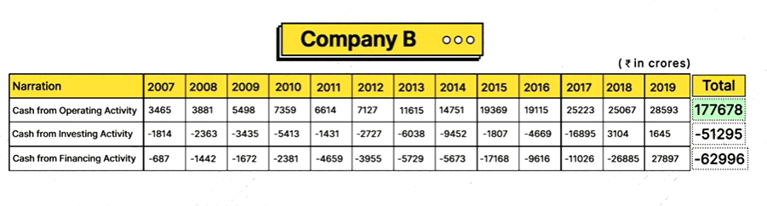

# **The connection between the balance sheet, P&L statement and cash flow statement**

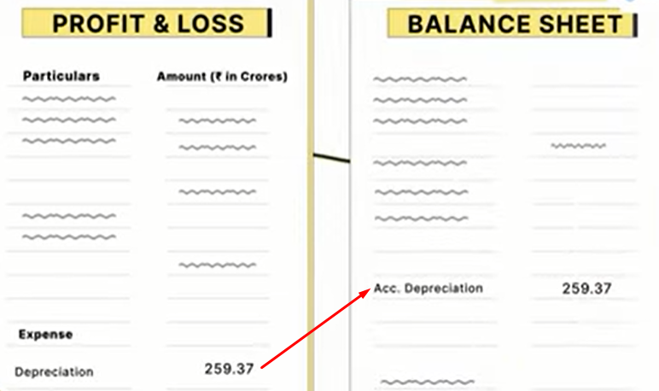

**Financial Ratios:** The ratios help to understand the financial health of the company.

**1. Profitability Ratio:** Helps to understand the profitability of the business.   
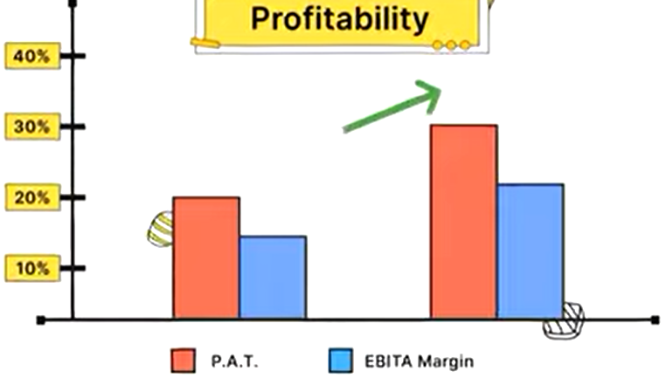

1. **Operation margins** = (total income - total expenses) / Revenue by operations
2. **Profit after tax margins** = PAT / Total Income
3. **Return on Equity** = PAT / Total Equity

**Good Company will have growing PAT.**

**Higher the ROE higher the returns, making sure that the company don’t have debt. The minimum ROE accepted is 25%.**

**2. Leverage Ratios / Solvency Ratios:** helps to measure the efficiency of the business.

1. **Interest Coverage Ratio =**  (total income - total expenses) / finance cost of the company.

A higher interest coverage ratio, tells the company making good interest.

1. **Debt to Equity Ratio** = Debt / Equity

Value > 1 tells the company to have more debt and vice versa.   
**Lower the better.**

**3**. **Valuation Ratio**: The stock price of the company is compared to the valuation of the company. This helps to identify the fair value of the stock price.

1. **Price to Sales =** Current share price of the company / Sales per share

* We need to calculate the sales per share of the company before

**Sale per share =** total sales/total no. of shares outstanding in the market

**Note: If stock is overvalued, we can check its performance with peer companies and see if it is still overvalued or undervalued and invest accordingly.**

1. **Price to Book** = share price / Book Value

Where book value is the amount left after the company pays all its obligations (Tangible Asset - Liabilities )

**Book Value** = total equity / total outstanding shares

A lower price-to-book value ratio signifies that the firm is undervalued with respect to the company’s equity/ book value.

1. **Price to Earning(PE Ratio) = share price / EPS**

**EPS (Earning per share) =** Profit after tax (PAT) / total outstanding shares

**(check PE ratios of Nifty)**